CSA-1557 CLOUD COMPUTING LAB PRACTICAL

9.Create a simple cloud software application for Hospital information system for SIMATS Hospital using any Cloud Service Provider to demonstrate SaaS with fields of patient name, age, address, phone, email, Attender name, attender phone, doctor name, diseases, etc

STEP-1:

Login into zoho.com and create an account.Then go to zoho creator and create a new application starting with a new form.Add or insert the required fields.

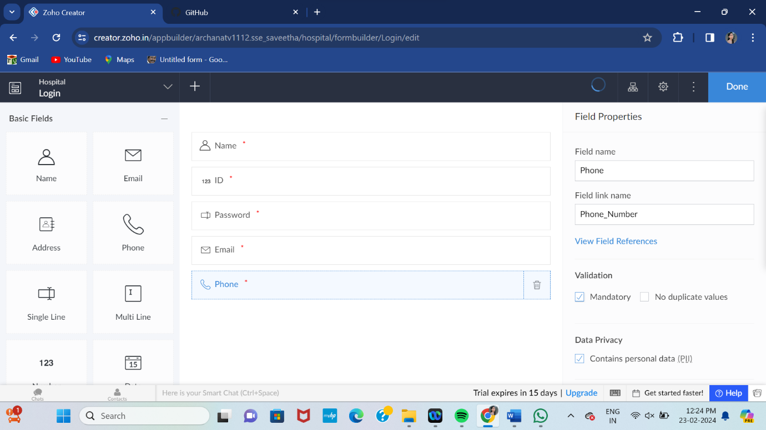

STEP-2:

Execute or run the model and get the required login form in live.

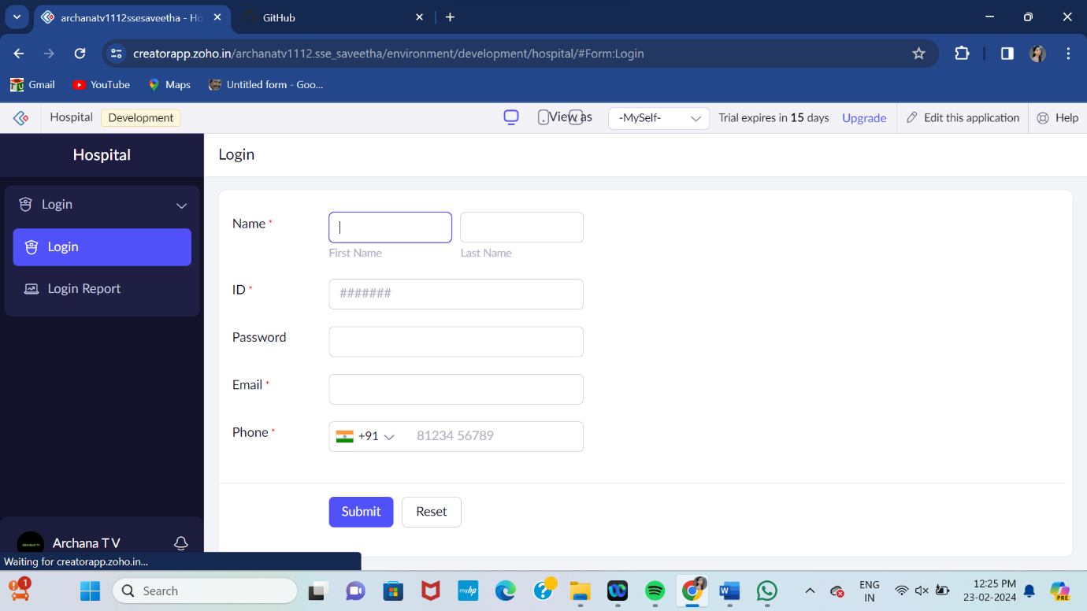

STEP-3:

Next step is to add another form which consists of appointment bookings with the fields.

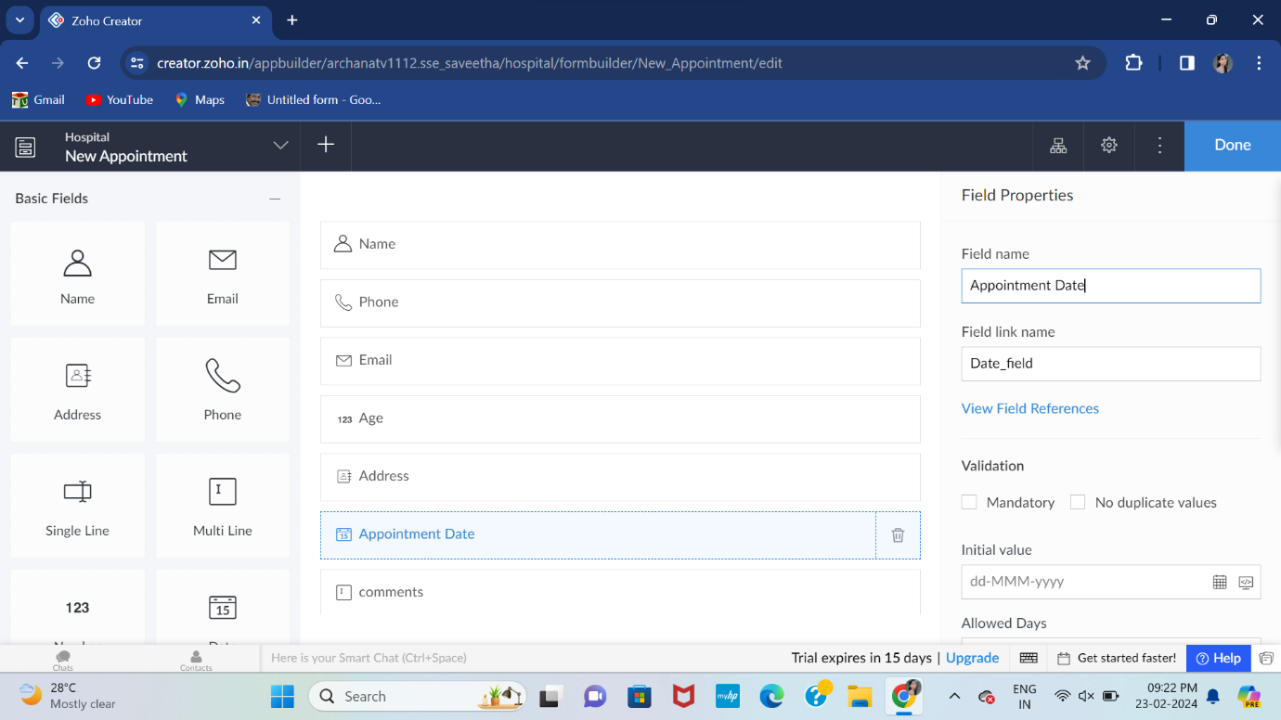

STEP-4:

Execute or run the model and get the required appointment details from live.

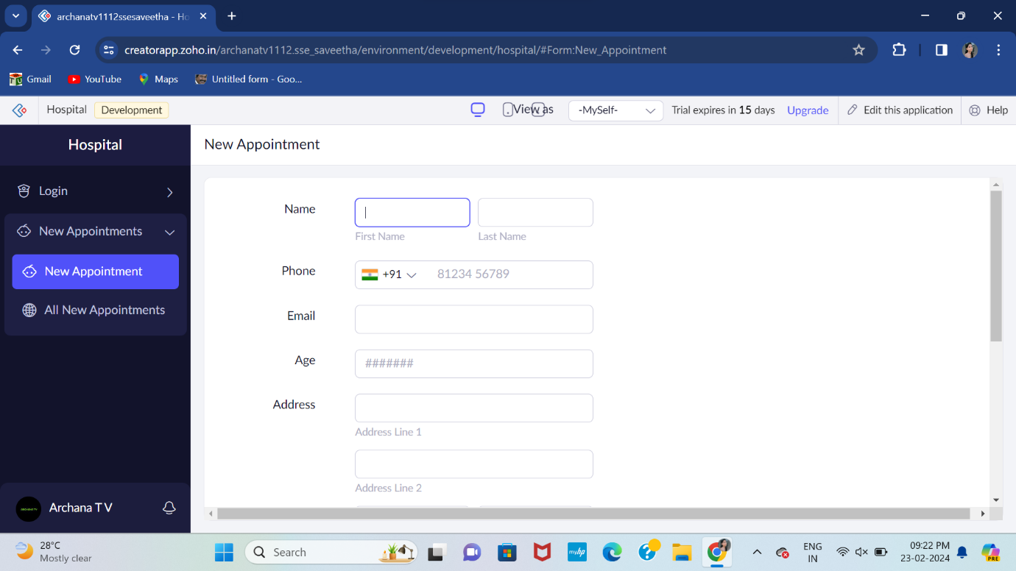

STEP-5:

Next step is to add another form which consists of course medical details with the fields.

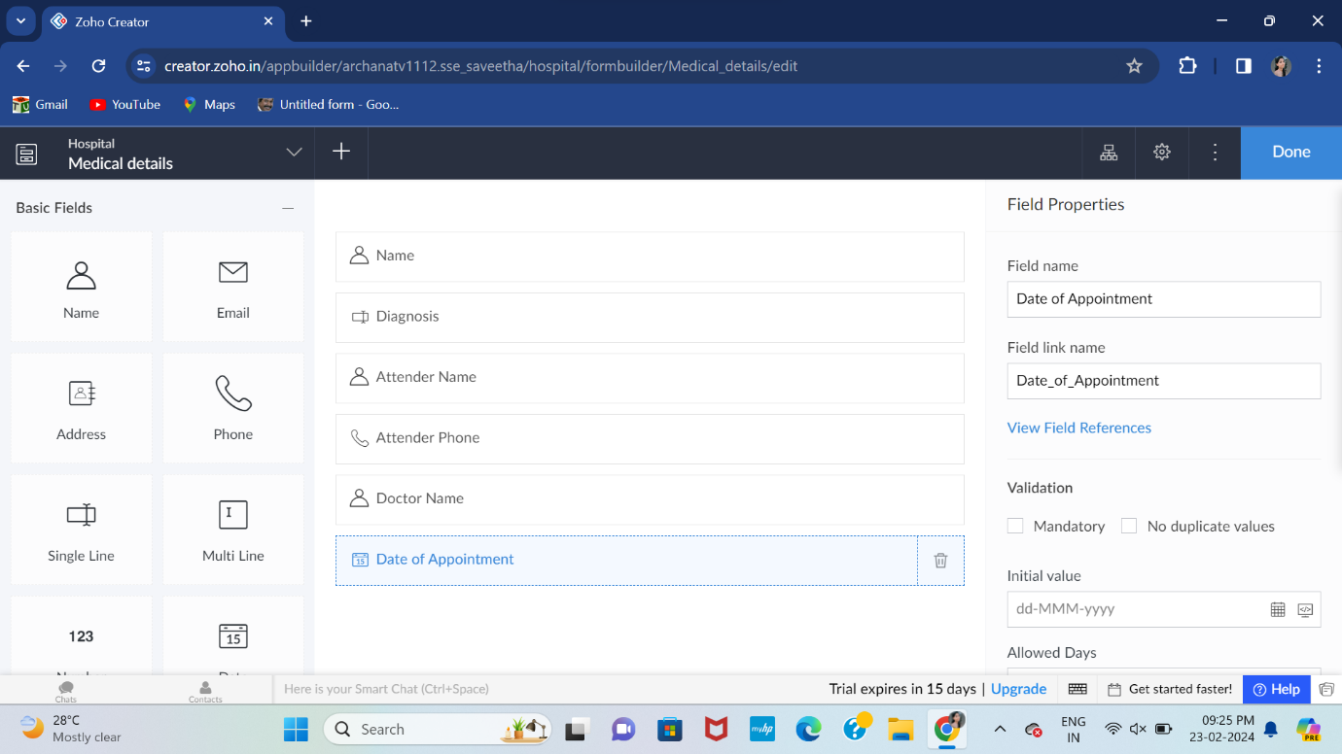

STEP-6:

Execute or run the model and get the medical details from live.

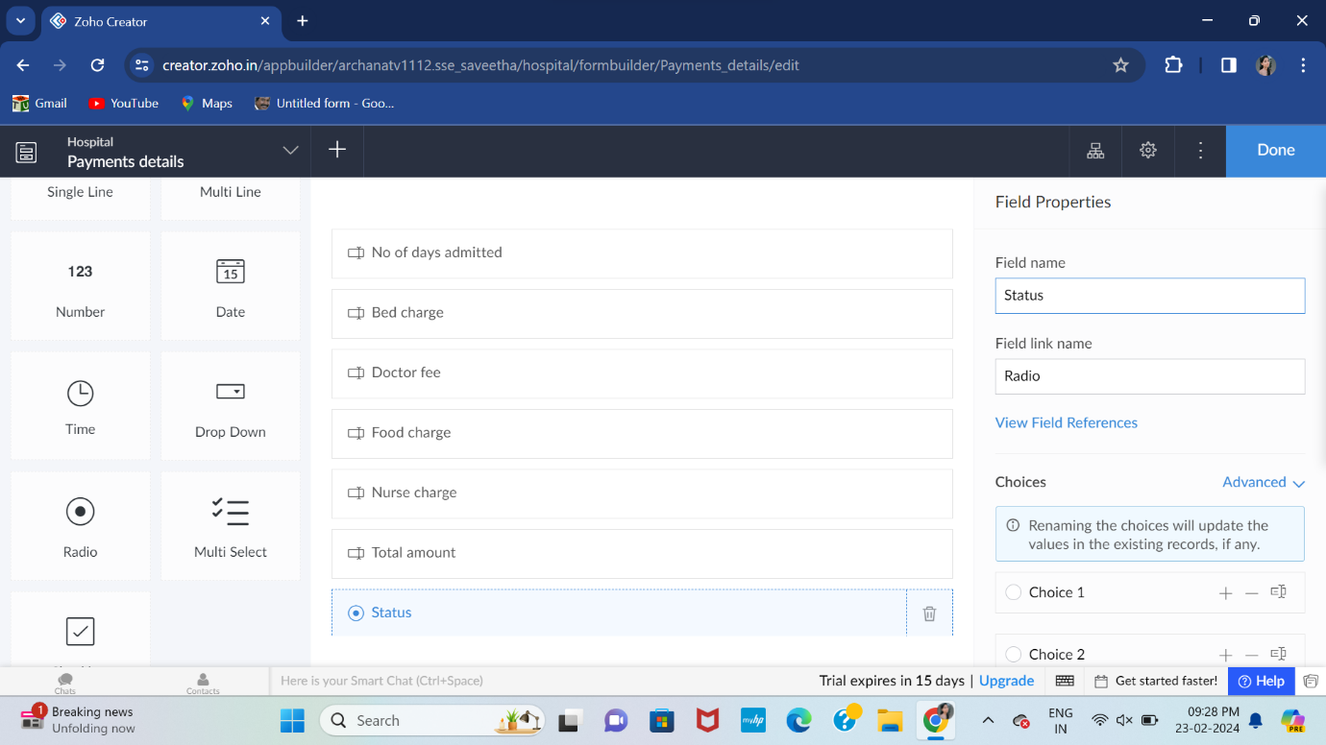

STEP-7:

Next step is to add another form which consists of payment details.

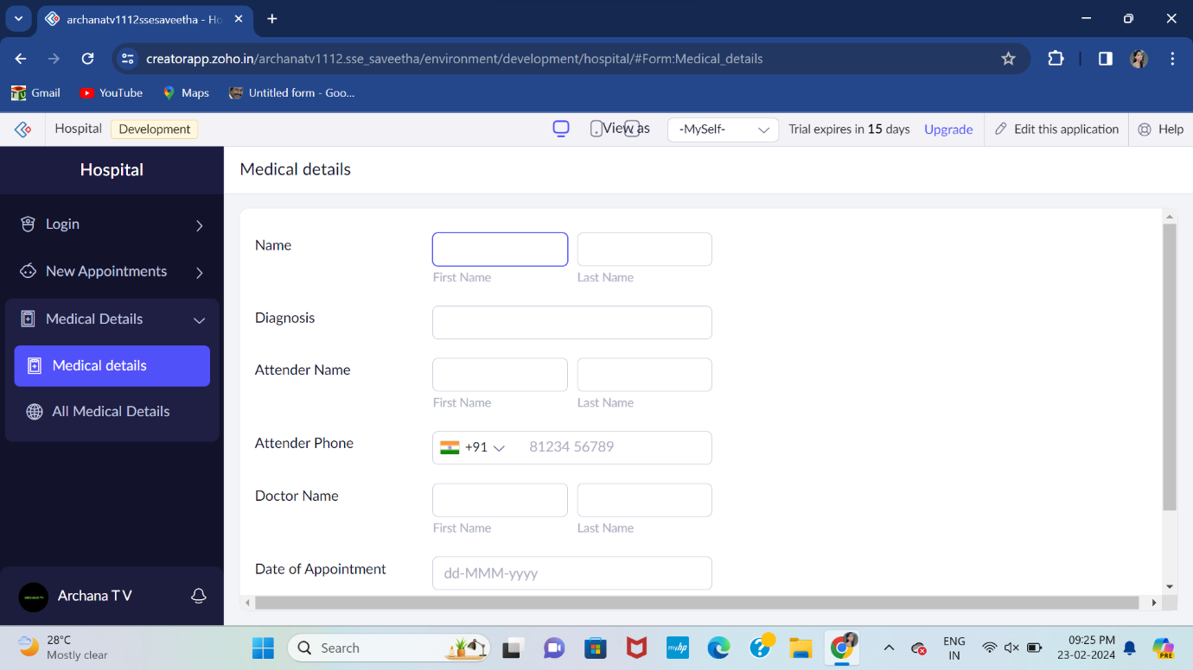

STEP-8:

The last step is to run and execute the payment details form and end the program.

